CellSim

Species Stat Line Currency and Predictive AI Meeting Brief
Decision brief for the project planning meeting during the week of 21 September 2026
STATUS | OWNER | LAST UPDATED
Proposed for planning decision | CellSim project | 17 September 2026

Prepared for | Josh and Sim
Evidence baseline | Current ProjectMain working-tree planning and implementation state reviewed 17 September 2026
Related records | Roadmap, Sprint 3 control record, Stat Line contracts, Scientific Data Economy, and Predictive AI research plan
Decision sought | Approve the operating boundary, near-term prerequisites, sequencing, and ownership for shared evidence work

1 Executive summary
Recommendation: keep the Species Stat Line, scientific-data currency, and Predictive AI on one evidence spine but in separate authority layers. The Stat Line records what happened. A versioned currency policy decides what selected observations are worth. Predictive AI forecasts and explains outcomes. Josh and Sim retain the authority to decide what is balanced, understandable, and ready for production.
This boundary lets the three efforts reinforce one another without allowing a payout formula or an AI score to redefine the simulation evidence. It also matches the current roadmap: Sprint 3 is closing the expedition contract and readability gaps; build and species calibration follow in Sprint 4; player comprehension follows in Sprint 5; production settlement and the first persistent Genome unlock remain Sprint 6 work. Predictive AI feature F20 stays on hold until the core loop, economy, and metric meaning are stable. [1][2]

Goals and non goals
Goals | Non goals
Keep one trustworthy source for simulation facts and metric validity. | Choose a final payout formula in this meeting.
Make currency valuation versioned, replayable, and replaceable without changing historical reports. | Turn APS, AHS, RFS, or final population into an overall species rating.
Give upgrade authors a matched-seed evidence loop for prediction, design, and balance. | Reopen P3 or claim generalized predictive capability from bounded experiments.
Define the gate for one future P4 design-translation experiment. | Implement production Genome effects, costs, settlement, or persistence ahead of their roadmap gates.

Decisions requested
1. Adopt the four-layer boundary: measurement, valuation, prediction, and human decision.
2. Authorize a small contract package before economy tuning: metric definitions, a currency-policy-v1 interface, a predator dictionary, and a historical EX-007 erratum.
3. Keep survivor-count currency as prototype plumbing only until a Forest Edge reference panel is approved and candidate policies are compared offline.
4. Keep F20 paused during Sprint 3; after the contract gate, either select one bounded P4 translation question or explicitly continue the pause.

2 Roadmap position
The work is technically connected but scheduled across different gates. The measurement foundation already exists. The economic meaning, player comprehension, and persistent Genome loop do not. Treating those as separate readiness states prevents an implemented field from being mistaken for an approved game rule.
Workstream | Current state | Role in this brief | Next gate
Species Stat Line | Implemented role-specific calculation and export paths | Measurement authority | Freeze the metrics used by currency and forecasts
Scientific-data currency | Approved direction; survivor-count reward is prototype | Human-authored valuation policy | Approve reward and settlement contract
Upgrade design and balance | Mutation foundation exists; broader promotion review remains | Uses matched evidence to author tradeoffs and costs | Forest Edge reference panel and S4 co-design
Predictive AI | P0-P3 bounded complete; P4-P6 not started | Advisory forecast and diagnosis | One new human-owned P4 contract
Genome progression | Identity, profile snapshot, catalog, and UI foundation exist | Later consumer of approved settlement and balance | S6 persistent unlock and activation

What is already implemented
- Herbivore and predator Stat Lines use shared domain calculations for game display and export; phase and final windows are separate in the continued-world runtime. [4][5]
- The run result carries player population and currency earned, and the preview applies that value at phase boundaries and terminal completion. [10]
- The current factory sets currency earned equal to the surviving player population. This proves the reward path, not a validated economy. [3][10]
- The Genome identity, per-species profile, immutable launch snapshot, catalog, and Gene Lab display foundation are already recorded as complete. Production content, actions, costs, and persistence remain later work. [1][2]

Readiness judgment
The project is ready to define and test policy contracts against existing reports. It is not ready to lock final earning rates, use composite Stat Line scores as payout multipliers, or promote Predictive AI into production design authority.

3 Stat Line and currency
The Stat Line is most valuable when it remains descriptive. It tells designers what happened, over which window, with which inputs, and whether a derived value is valid. Currency is prescriptive: it decides which observations deserve reward and how much. The policy can read immutable Stat Line evidence, but it must not change metric meaning or overwrite a report.
Layer | Question answered | Owned output | Must not become
Raw evidence | What events and counts occurred? | Deaths, births, encounters, attempts, populations | A reward decision
Derived diagnostics | How should related facts be summarized? | Ratios, composites, and validity states | A universal quality score
Currency policy | What player behavior is worth data? | Versioned payout with caps and settlement | A second metric definition
Human review | Is the outcome balanced and fun? | Accept, revise, reject, or defer | An automatic consequence of one number

Minimum currency policy contract
A small currency-policy-v1 record should make tuning explicit and reproducible. It should contain:
- A policy ID and version tied to the ruleset, scenario, metric dictionary, and window.
- Exact metric IDs with validity, not-applicable, and role handling.
- Reward categories, thresholds, caps, diminishing returns, and discovery rules.
- Unique phase and final settlement IDs so repeated views cannot pay twice.
- A dry-run output from retained reports with no progression or simulation write.

Currency design guardrails
- Do not pay raw tick count or uncapped common events.
- Do not treat final population as universally better; it needs a target band.
- Do not make APS, AHS, or RFS a direct multiplier.
- Compare candidate policies offline on the same retained seed panel.

Known semantic debt
The current machine-readable dictionary defines RFS as Replication fitness score and APS as Actual prey score. The historical EX-007 report instead labels them Resource-finding score and Activity per step. Its accepted direct-outcome findings remain bounded evidence, but those two composite interpretations should not be reused. Add a separate erratum and preserve the original package. The machine-readable dictionary is also herbivore-only; the predator contract exists in prose and should receive an equivalent versioned dictionary before cross-role consumers depend on it. [4][5][6][9]

4 Upgrade design and balance
Stat Lines can make upgrade authoring more deliberate without reducing design to optimization. Their practical role is to show which tradeoff changed, where a benefit moved a cost, how variable the result is across seeds, and whether an effect survives a matched comparison. Designers still choose the desired play pattern and acceptable ecological consequences.
Step | Designer task | Evidence check
1 Intent | State the intended decision, benefit, cost, and species fantasy. | Define success and failure before the run.
2 Freeze | Author the upgrade, scenario, seed roles, timing, and comparison scope. | Capture ruleset and immutable launch snapshot.
3 Measure | Run baseline and variant on the same cases. | Use raw counts, validity states, distributions, and direct outcomes.
4 Interpret | Ask whether the effect is readable, viable, and ecologically acceptable. | Keep observed fact, inference, balance judgment, and player value separate.
5 Revise | Change data, costs, tradeoffs, or presentation and retest. | Create new evidence; do not rewrite the previous report.

Composite metric boundary
Metric | Current meaning | Useful for | Not approved for
RFS | Replication fitness score | Reading population change with birth conversion | Direct payout or universal fitness rank
APS | Actual prey score for herbivores | Summarizing applicable replication and survival components | Cross-role comparison or species verdict
AHS | Actual hunt score for predators | Summarizing hunt, replication, starvation, and crowding components | Pooling with APS without normalization
FPO | Final population in one window | Direct outcome and accounting reconciliation | Assuming that higher is always better

5 Predictive AI research
The research program asks whether deterministic simulation plus an auditable AI workflow can help a small team discover, test, explain, and promote better rules without surrendering human design authority. Its organization is intentionally evidence-first: Experiment, Run, Report, Analysis, and Human Decision are different artifacts with different owners. [7]
Phase | Status | What it establishes | Promotion boundary
P0 | Complete | IDs, hypothesis framing, ownership, and decision protocol | Program can run bounded studies
P1 | Complete within bounds | Reproducibility, fingerprints, replay, and known telemetry limits | Instrument trusted only within recorded coverage
P2 | Complete within bounds | Evidence-backed diagnosis of a bounded ecology outcome | Explanation does not imply general cause
P3 | Closed as bounded | Forecasts, order effects, thresholds, and human approval workflow | No generalized predictive or balance capability
P4 | Not started | Translation into upgrade, event, explanation, or curator candidates | Needs a fresh human-owned contract
P5 | Not started | Repeatability across scenarios and contributors | No automatic promotion from P4
P6 | Not started | Decision on product, tooling, process, or external review | Production use remains a new gate

What the research can provide
- Faster evidence: track time, manual steps, reruns, review burden, and decision rate.
- Better diagnosis: cite reports, run controlled follow-ups, and measure unsupported-cause errors.
- Earlier warnings: use held-out tests, range coverage, confidence, and out-of-distribution checks.
- Clearer player explanations: translate accepted evidence and validate comprehension in playtests.

Conditions before the next predictive study
Before another confirmatory study, either close or explicitly accept the remaining evidence-hygiene gaps: versioned metric definitions, a sealed AI context manifest, a seed registry, event-level scoring, endpoint families, complete provenance, and raw-artifact retention. The roadmap adds a production gate: core loop, economy, and metric meaning must be stable enough to make the result useful. [1][7]

6 Overlap opportunity and risk
The strongest overlap is shared evidence and experimental machinery. The weakest overlap should remain decision authority. Currency and Predictive AI may consume the same immutable reports, but they answer different questions and should not share one opaque score. [8]
Dimension | Overlap | Shared value | Boundary
Metrics and provenance | High | One dictionary, seed, ruleset, window, and validity contract | Consumers do not recalculate formulas
Batch and comparison tooling | High | Matched panels support payout tests, balance tests, and forecasts | Each consumer keeps separate outputs
Hypothesis formation | Medium | Prediction misses can expose missing telemetry or unclear labels | AI proposals need human pre-approval
Player explanation | Medium | Accepted evidence can support readable cause and effect | Research scores stay out of player UI
Design authority | Low by design | Evidence informs the decision | Humans approve balance, payout, fun, and promotion

Primary risks and controls
Priority | Risk | Smallest control
P0 | Metric semantic drift produces official-looking but wrong scoring. | Version definitions; add an EX-007 erratum; reject unknown versions.
P0 | One composite becomes a payout, species verdict, or AI success score. | Show raw and per-stat outcomes first; keep composites secondary.
P0 | Policy or evaluation writes back into run state or past evidence. | Run consumers after completion and save separate versioned outputs.
P1 | APS and AHS are pooled across roles without normalization. | Keep role-specific contracts and require an explicit comparison design.
P1 | A reference panel is overfit and treated as general balance. | Rotate held-out seeds and scenarios; label valid ranges and freshness.
P2 | Research diagnostics leak into player UI as species ratings. | Use only human-approved explanations in player surfaces.

7 Combined operating model
The combined model uses one immutable evidence spine and several narrow consumers. It creates leverage because every new trustworthy report can support explanation, economy calibration, upgrade review, and future prediction without duplicating the simulation formulas.
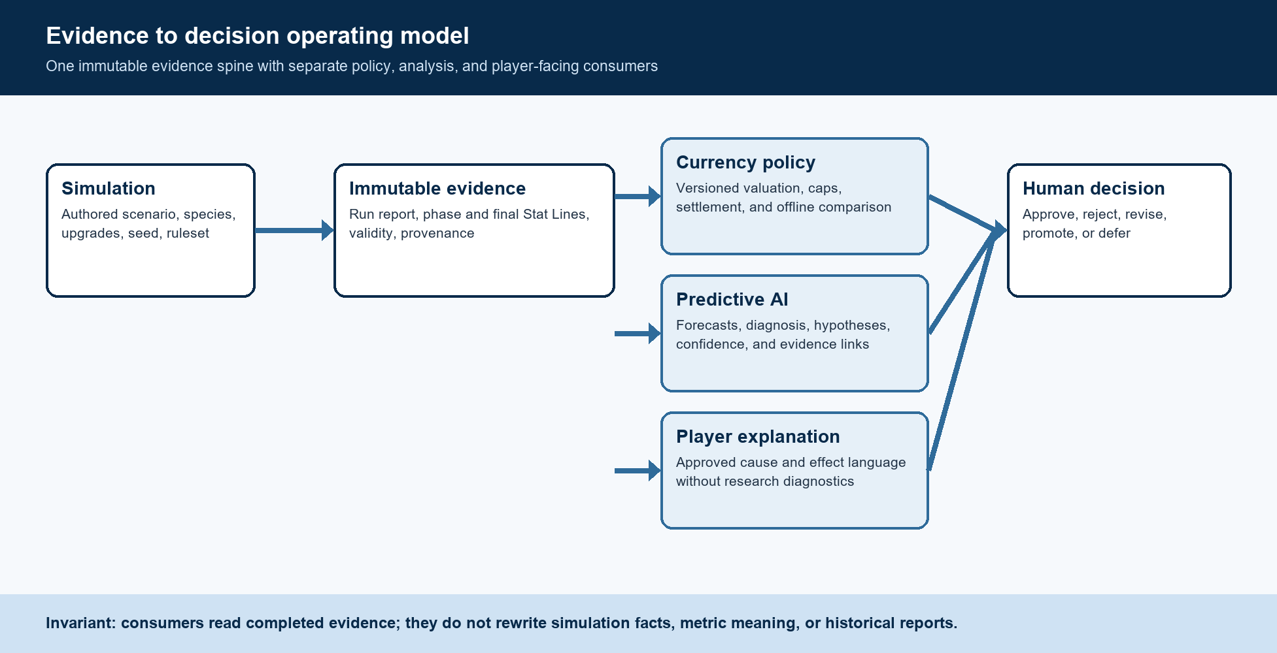
Figure 1 Evidence to decision operating model

Recommended delivery sequence
When | Deliverable | Exit evidence
Now in S3 | Freeze consumed metric meanings; draft currency-policy-v1; add predator dictionary and EX-007 erratum. | Every policy input has a stable ID, window, unit, status rule, and provenance.
S4 | Approve a Forest Edge reference panel; compare payout candidates offline; run matched-seed upgrade reviews. | Human decision records select or reject candidate policies and upgrade changes.
S5 | Validate player-facing cause and effect language. | A comprehension playtest can identify role, pressure, selected effect, and outcome cause.
S6 | Implement versioned settlement and the first persistent Genome unlock. | One Hare unlock survives restart, toggles between runs, and applies only when active.
Later gate | Run one P4 question, then P5 or P6 only if separately approved. | Evidence shows workflow value beyond one fixture before production promotion.

8 Meeting decisions and evidence register
A useful meeting outcome is a small set of explicit approvals, not a final balance model. Record each decision with its scope and the evidence it authorizes.
Decision | Recommended disposition | Owner to confirm
Operating boundary | Approve measurement, valuation, prediction, and human review as separate layers. | Josh and Sim
Metric contract work | Approve the small S3 package and preserve historical reports with an erratum. | Sim for meaning; Josh for consumers
Currency status | Keep survivor-count rewards as prototype plumbing until offline calibration passes. | Josh with Sim review
Predictive AI timing | Keep F20 on hold during S3; decide after the contract gate whether one P4 question earns capacity. | Josh and Sim
Genome dependency | Do not make production Genome progression depend on unapproved payout or predictive scores. | Josh with Sim review

Evidence boundary
This brief reflects the current ProjectMain working-tree planning and implementation state reviewed on 17 September 2026. It does not replace the roadmap, sprint control record, formula contracts, research plan, experiment packages, or human decision records. Where a historical report conflicts with the current versioned metric dictionary, the dictionary controls new work and the historical record remains unchanged with an added erratum.

Source register
No | Record | Used for
1 | Production roadmap  ROADMAP.md | Milestones, Sprint 4 to Sprint 7 horizon, feature status, and F20 hold.
2 | Sprint 3 control record  docs\Sprints\S3-control-record.md | Active scope, delivery order, Genome boundary, and no new predictive experiment.
3 | Scientific Data Economy  docs\SCIENTIFIC_DATA_ECONOMY.md | Approved direction, prototype survivor reward, settlement questions, and Genome dependencies.
4 | Herbivore Stat Line contract  docs\HERBIVORE_STATISTICS_VALIDATION.md | Formula, validity, export, evidence, and applicability boundaries.
5 | Predator Stat Line contract  docs\PREDATOR_STATISTICS_VALIDATION.md | Role-specific AHS formula and cross-role normalization warning.
6 | Metric dictionary version 1  docs\Research\METRIC_DICTIONARY_V1.json | Machine-readable herbivore metric names, units, windows, directions, and statuses.
7 | AI-Assisted Ecology Laboratory Research Plan  docs\Research\AI_ASSISTED_ECOLOGY_LAB_RESEARCH_PLAN.md | Hypothesis, protocol, phase gates, benefits, limits, and next-selection conditions.
8 | Stat Line and Predictive AI concern record  docs\Planning Concerns\STATLINE_PREDICTIVE_AI_CROSSOVER.md | Active overlap guardrails, ownership, and first-pass recommendations.
9 | EX-007 report and analysis  docs\Research\Experiments\EX-007-Predictive-Statline-Interventions | Historical labels, measurement correction, direct outcomes, and bounded decision context.
10 | Currency implementation path  SimulationRunResult.cs and SpeciesSimulationPreview.cs | Current survivor-count currency assignment and phase or terminal application.

Use footnotes for definitions, assumptions, or terms that need precision without interrupting the main narrative.

